# **Rangahau Āwhinatanga/Research Mentorship at the School of Nursing**

## Overview

The purpose of this document is to provide a brief overview of āwhinatanga/mentoring that is relevant to the School of Nursing at the University of Auckland, Auckland, New Zealand. This document recognises the multifaceted rangahau/research that is undertaken within the school and the range of mentoring requirements and preferences that staff may have. We take a bicultural approach and draw from the metaphor of weaving a tukutuku (outlined below) to describe the values and outcomes associated with mentoring. The document also draws from international mentoring literature and two local and national documents: The University of Auckland guide to mentoring[1] and the New Zealand Nurses Organisation Mentorship/Āwhinatanga educational and professional development guideline[2].

## Definition

Āwhinatanga/mentoring is a relationship that helps staff to thrive in a safe and supportive environment and can facilitate growth and development. We recognize the important role of āwhinatanga/mentoring in supporting mana (status, prestige, influence) for individuals, their whanau (families), and wider communities (iwi, hapu)[3].

## The process of weaving tukutuku

Tukutuku is a traditional craft of raranga (weaving) using reed latticework to generate decorative wall panels. Tukutuku are a taonga (treasured object) “underpinned by the principle of whakapapa (layers or descent lines), which in turn is based on a specific body of mātāpono (principles)”[4]. In order to create tukutuku, you must bring your “best self”, and be ready to work in partnership with another weaver. The process involves at least two weavers, one working from either side of the panel. Both weavers are integral to the process, recognizing that you cannot create beauty on one side of the panel without the other. Generally one weaver takes responsibility for guiding the process. Weaving a tukutuku is extremely time-consuming, requiring patience and clear whiti whiti korero (backwards and forwards communication). Plans and protocols must be established at the outset (e.g., pattern, colours). Understanding the whakapapa, the history and context of the tukutuku is essential to the planning process. In some cases, tumatahuki (central vertical stake) are lashed to the panel, in order to support the panel’s strength and stability [5]. The resulting tukutuku represents a taonga of significance, which has its own life, its own meaning, and is of significance to its community.

## Key principles of rangahau āwhinatanga/research mentorship

**Whanaungatanga**

Mutual trust, building a relationship, through shared experiences and working together, which provides people with a sense of belonging. Each person understands their role in the weaving of the tukutuku and works together with a shared purpose.

**Whakapapa**

Acknowledging history and backgrounds of individuals and of the research can provide the context for activities, or be a key driver and element of activities and outputs. Whakapapa provides the foundation for tukutuku, the story to be told, which may include wairuatanga (spirituality) and underpins the activities that occur.

**Manaakitanga**

Manaakitanga encompasses reciprocity, sharing, being respectful, having generosity, care, and kindness. Weaving tukutuku takes time and patience, requiring weavers to encourage and enable each other, and provide help, feedback and support to complete the tukutuku.

**Rangatiratanga and Māhakitanga**

Having leadership and dignity as well as humility and reciprocity are key elements of the mentoring and weaving processes. It is important to recognize that all people involved in the process have something to contribute and to value their input.

**Kotahitanga**

Weaving requires unity, togetherness, solidarity, and collective action. Developing a shared vision and plan to achieve this vision, and making a commitment to the vision enable goal(s) to be realised.

**Kaitiakitanga**

Weavers are the kaitiakitanga of the panel and its whakapapa, as the mentor and mentee are the guardians of the research. Kaitiakitanga involves guardianship, stewardship, and trust.

**Te pono**

Having integrity, and being genuine and sincere with each other and about the research/weaving process, activities, and outcomes is fundamental to progressing activities in a meaningful way.

**Korero mai**

Speaking up, ensuring effective, regular, and open communication is essential, recognising this is fundamental to achieving the desired pattern/outcome.

## Activities and benefits of āwhinatanga/mentoring

Generally, the kai rangahau/mentee instigates āwhinatanga/mentorship. Potential mentoring activities and benefits of āwhinatanga for kai rangahau are wide-reaching and vary depending on the relationship and individual requirements and stages. Activities might include support in developing a career pathway after postgraduate study, facilitation of networking, working on strategic thinking around research pathways, providing opportunities for critical reflection, general collegial support, or sharing insights about a profession or research field. Ultimately āwhinatanga can result in mentees’ increased skills, knowledge, confidence, and career satisfaction; development of leadership skills and networks, greater career success, feeling more connected, and a more in-depth understanding of the research context. Kai arahi rangahau/mentors can also benefit from these outcomes, as well as additional benefits through satisfaction from supporting the development of others, sharing knowledge and skills, and professional recognition of service.

## Key kai arahi rangahau/research mentor attributes

Relationships and building a sense of whanaungatanga are fundamental to effective mentoring. Kai arahi rangahau/mentors can be peers, elders, whānau leaders, academics, community members, or professional leaders. When identifying a potential kai arahi rangahau, some key considerations and attributes to look for are:

* Respectful and non-judgmental (manaakitanga)
* Integrity (te pono)
* Discreet and respects privacy and confidentiality
* Compatibility (for example an understanding of the area you are seeking guidance in)
* Commitment to the mentoring relationship
* Time availability in the context of existing academic and community roles and expectations
* A sincere and genuine interest in the kai rangahau/mentee’s success/wellbeing/growth and development (te pono; as defined by the kai rangahau)
* Flexible and adaptable
* Good interpersonal and communication skills, including active listening (whakarongo/listen)
* Organised
* Commitment to own learning, growth, and professional development

## Factors to consider when establishing an āwhinatanga/mentoring relationship

The [University of Auckland Guide to Mentoring](https://cdn.auckland.ac.nz/assets/auckland/business/current-students/PDFs/mentoring-guide-final.pdf) provides useful documents to help navigate establishing a mentoring relationship, including a Mentoring Agreement (Appendix E in the University of Auckland Guide to Mentoring), Mentoring Diary (Appendix F), Expectations of the Mentee (Appendix C), Expectations of the Mentor (Appendix D), and a Mentoring Progress Plan (Appendix G). Key considerations include:

* Expectations of the mentor and mentee
* Clear boundaries or limits to the relationship
* Avoiding over-dependence
* Duration of mentoring, how to deal with opting out
* Preferred communication styles
* Goals of the mentoring relationship
* Resources required
* Frequency and method of meetings/contacts

# Links to further help and information

* The University of Auckland [Guide to Mentoring](https://cdn.auckland.ac.nz/assets/auckland/business/current-students/PDFs/mentoring-guide-final.pdf)
* The University of Auckland
* New Zealand Nurses Organisation [Mentorship/Āwhinatanga Professional Guideline](https://www.nzno.org.nz/LinkClick.aspx?fileticket=BxYYxkAHhzE%3D&portalid=0)
* University of Auckland [Alumni Connect](http://connect.auckland.ac.nz/) – an online mentoring tool currently in development that will connect the University of Auckland alumni seeking career advice with other alumni willing to share their experience and expertise.
* Visit [Career Tools](https://uoa.csod.com/) for mentoring training opportunities, including:
  + Developing successful mentoring practice
  + Successful academic mentoring
  + Workshop for continuation mentors
* Some literature reviews on mentoring that may be of interest:
  + A [literature review](https://www.ncbi.nlm.nih.gov/pubmed/28931480) of mentorship programs in academic nursing
  + Workplace mentoring: a [literature review](https://ako.ac.nz/assets/Knowledge-centre/RHPF-n33-Professional-development-for-mentors-in-industry/957c864e6b/Workplace-Mentoring-a-literature-review.pdf)
  + A [systematic review](https://link.springer.com/article/10.1007/s11606-009-1165-8) of qualitative research on the meaning and characteristics of mentoring in academic medicine

# Acknowledgements

This document was created by Dr Kim Ward, Dr Bobbi Laing, Dr Tess Moeke-Maxwell, and Associate Professor Melody Smith, of the School of Nursing, University of Auckland. The authors would like to acknowledge the time and support of Kuia Whio Hansen for providing cultural advice on the model.

# School of Nursing Āwhinatanga/Mentoring model

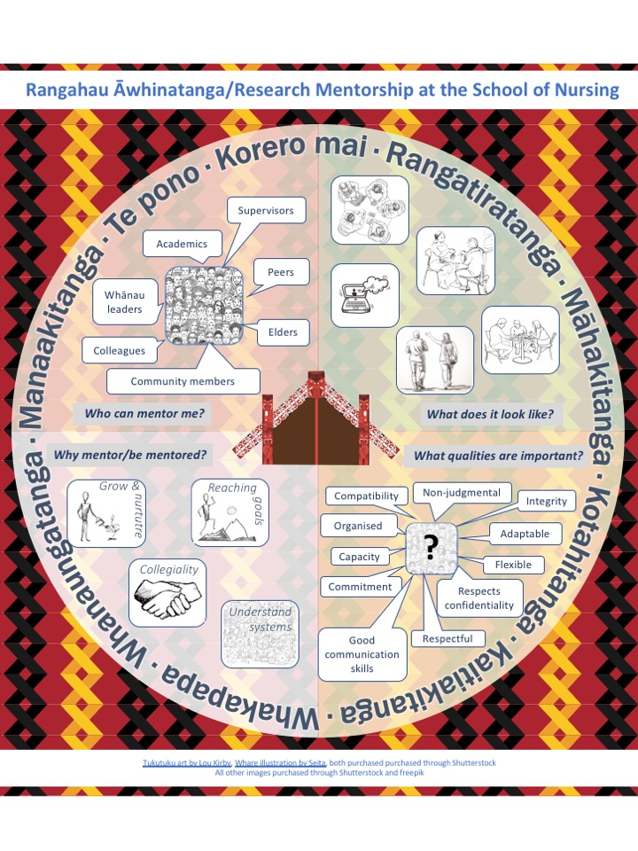

1. Moorcroft, M., Crick, M. A. (2014). The University of Auckland. A Guide to Mentoring. Auckland, New Zealand: HR/People and Organisational Development, University of Auckland.
2. Clendon, J., Turner, N. (2013). NZNO Education & Professional Development Guideline: Mentorship/Āwhinatanga. Wellington, New Zealand: New Zealand Nurses Organisation.
3. Hook, G. R, Waaka, T., & Raumati, L. P. (2007). Mentoring Māori within a Pākehā framework. *MAI Review, 3*(1).
4. ### Boyd, P. M. (2010). Tukutuku : He whai toi, he toi tupu = In pursuit of an understanding of Māori art practices. PhD Thesis, University of Auckland, Auckland, New Zealand.

  
5. http://christchurchcitylibraries.com/Maori/Puawaitanga/Tukutuku/