Master of Information Technology
Orientation and Enrolment

This document contains important information for all Master of Information Technology students.

Page 1 contains a course enrolment form to be completed with the courses you intend to take. The form should be completed after taking advice from the programme advisors.

Pages 2 onwards contains essential information about the Master of Information Technology programme and advice for making course selections.

Enrolment Approval Form (EAF)
Master of Information Technology

Once you have accepted your offer into the Master of Information Technology programme, you need to choose the courses that you intend to take. Please read this document thoroughly, and do the following.
Initially, email us at (ictcourseadvice@auckland.ac.nz) and include:
- Where available, a copy of your transcript(s) detailing prior studies.
- Any areas that you’d like to focus on in the Masters degree.
- Where known, the courses that you intend to take or are interested in taking. Include these in the table below and attach a copy of this completed form to the email.
A programme advisor will help you to identify suitable courses. They will need to approve your course selections before you enrol in courses on Student Services Online (SSO). The programme advisor will then email the appropriate enrolment team with the list of approved courses.
Once approved (and not before), you can enrol in courses on SSO. Note that some courses will require you to apply for enrolment concessions on SSO. The concessions are subject to approval by individual schools/faculties. You must contact the advisor for any changes in enrolment. Any COMPSCI concessions without approval will be declined immediately. Any timetable clash will be declined by the University. Please check the final course availability and timetable on SSO.
Please note that this form is not a manual enrolment form, but an indication of your intended course of study.

Student Name: Your Name
ID: Your ID
Programme: 120/180/240pt Full-time/Part-time
Expected Internship Semester and Year: Internship semester Internship year
Signature: Sign here
Date: Enter a date.

Proposed Course of Study
First semester |  | Second semester
Course # |  | Course #
Course # |  | Course #
Course # |  | Course #
Course # |  | Course #

Orientation Information
Master of Information Technology

The remainder of this document contains useful information about the Master of Information Technology programme and other information to help with choosing courses. It’s structured as answers to this set of questions.

General information

- What are the requirements for completing the Master of Information Technology?

- What are the Masters of Information Technology regulations?

- What are the programme workshops?

Course selection

- What do I need to know when choosing my courses?

- What are the different kinds of courses that are available?

- Can I take courses other than those listed in the programme’s regulations?

- I’m a PGCertInfoTech graduate / 240-point Masters student. What courses should I take?

- I have limited Computer Science content in my Bachelors. What courses should I take?

- When do I enrol in the industry internship course?

- Can I change my enrolments once they’ve been approved?

- Do any courses have any “special” prerequisites?

- Are there any COMPSCI courses that I can’t take?

- What do I do about timetable clashes?

- What do I do if the class is full?

- When are courses offered?

- What are the recommended core courses if I want to focus on a specific area?

General information

What are the requirements for completing the Master of Information Technology?
You need to successfully complete the following in order to graduate with a Master of Information Technology degree:
- COMPSCI 718, COMPSCI 719, and 8 taught courses for 240-point students; 8 taught courses for 180-point students; 4 taught courses for 120-point students.
- Industry internship (COMPSCI 778).
- Participation in scheduled workshops.

The programme regulations below detail the courses that you can take, and the GPA requirement that’s necessary to proceed with the industry internship. During semesters, regular workshops are scheduled, and participation is considered mandatory.

What are the Master of Information Technology regulations?
A student who has to complete 240 points must satisfy the following requirements:
- 60 points: COMPSCI 778;
- 60 points: COMPSCI 718 and COMPSCI 719;
- at least 45 points from technical courses (see Table 1);
- at least 45 points from professional skill courses (see Table 2);
- up to 30 points from approved 600 or 700 level courses.
A student who has to complete 180 points must satisfy the following requirements:
- 60 points: COMPSCI 778;
- at least 45 points from technical courses (see Table 1);
- at least 45 points from professional skill courses (see Table 2);
- up to 30 points from approved 600 or 700 level courses.
A student who has to complete 120 points must satisfy the following requirements:
- 60 points: COMPSCI 778;
- at least 45 points from professional skill courses (see Table 2);
- up to 15 points from approved 600 or 700 level courses.
Note that there is a GPA requirement for continuation with the Masters programme. For 120-point and 180-point students whose GPA, calculated from their taught courses, is less than 4.0 will be awarded a Postgraduate Diploma in Information Technology. For Postgraduate Diploma students there is no requirement to complete COMPSCI 778. Where you fail to meet the 4.0 GPA requirement in your first semester, but it’s possible to achieve an overall GPA of 4 or above, based on a further semester of study, you may be given the opportunity to remain in the Masters programme. However, any internship will not be scheduled until the grades for all taught courses have been released. In practice this means that any internship will be delayed until the next scheduled intern period. If your performance in your first semester of study is considered poor, you will be switched to the Postgraduate Diploma in Information Technology and you will not be able to proceed with the industry internship.

For 240-point students, there are two GPA requirements for continuation with the Masters programme. You must first achieve an overall GPA of 4.5 or above from COMPSCI 718 and COMPSCI 719. If you fail to meet this requirement, you will discontinue the Masters programme and exit with a Postgraduate Certificate in Information Technology. The second GPA requirement is the same as the GPA requirement described for 120-point and 180-point students. You need to meet the 4.0 GPA requirement from all your taught courses, excluding COMPSCI 718 and COMPSCI 719, to remain in the Masters programme. Otherwise, you will be switched to the Postgraduate Diploma in Information Technology and you will not be able to proceed with the industry internship.

What are the programme workshops?
Programme workshops involve a range of activities that help prepare you for the internship and, more generally, industry life following graduation. Workshops include networking with companies; CV writing, interview skills and personal branding; guest speakers from industry and relevant professional bodies; professional ethics; information search, evaluation and report writing; and a final industry internship conference. There are usually 8-10 workshops each semester and they are scheduled on a weekday evening from 6pm.

Note that participation in workshops is assessed and forms part of your COMPSCI 778 industry internship grade.

Course selection

What do I need to know when choosing my courses?
Most importantly, you need to make sure that you have the necessary prerequisite knowledge for the courses you intend to study. Many of the technical courses have specialised prerequisites and assume that you’ve studied particular topics as part of your Bachelors degree.

The University Calendar lists every course that’s offered in the University. Using the Calendar you can see a particular course’s prerequisites in terms of other University of Auckland courses. Using this information, you can compare what you have studied with what is required for you to take a particular course. The Calendar is accessible at:
https://www.calendar.auckland.ac.nz

The professional skill courses tend not to have specialist prerequisites. In general, you can take most of the professional skill courses. We suggest that you choose from these based on your interests.

Other than ensuring that you have the necessary prerequisite knowledge for courses, you need to choose courses that meet the Masters of Information Technology’s regulations. Essentially, for 240-point and 180-point students, you need to take a total of 8 courses (excluding the internship course, COMPSCI 718 and COMPSCI 719), and at least 3 of these courses must be from the technical skills category and at least 3 from the professional skills group. For 120-point students, you need to take 4 courses, of which at least 3 must be professional skill courses.

To find more information about individual courses, you can search through the University’s Course Outline: https://courseoutline.auckland.ac.nz/dco

What are the different kinds of courses that are available?
There are two basic categories of courses: technical and professional skills. Technical courses are concerned with IT subject knowledge, and include areas such as software development, security, data management etc. Professional skill courses complement the technical courses and focus more on business, management and entrepreneurship. Our industry advisors have emphasised the importance of the professional skill courses as they are the courses that will help you land your first role in industry.

Courses are drawn from several faculties and schools, including Science, Business and the Medical School.

Figures 1 and 2, on page 7, cluster the courses that are offered. Using the clusters, you can identify particular courses that might interest you. For example, if you want to pursue a software developer role after graduating, you might include COMPSCI 701, COMPSCI 711 and COMPSCI 732 in your schedule. Given that there are many courses, you probably want to take courses from multiple clusters so as to have broad subject coverage. For example, with the above Software Development courses, you might also include courses from the Security and Artificial Intelligence clusters, perhaps dropping one of the Software Development courses.

Some of the courses in any one cluster complement the others in that cluster, while others tend to be mutually exclusive. For example, from the Security cluster, INFOSYS 727 provides general and broad coverage of security in modern information systems, whereas COMPSCI 702 is a more specialist course that addresses security in the context of mobile devices. Hence, INFOSYS 727 and COMPSCI 702 are complementary (i.e. you could take both courses if you’d like to specialise in security).

Can I take courses other than those listed in the programme’s regulations?
Yes, you can. However, most students tend to stick with the courses explicitly named in the programme’s regulations.

For 240-point and 180-point students, you can take up to 2 courses (30 points) outside of those courses explicitly listed in the regulations. For 120-point students, you can take one such course (15 points).

We will approve courses outside of those listed in the regulations as long as they are relevant to Information Technology and complement your other courses. For example, some students who take Data Management and Artificial Intelligence courses also take a Statistics (STATS) course as this is a complementary choice.

I’m a PGCertInfoTech graduate / 240-point Masters student. What courses should I take?
The PG Certificate in Information Technology provides a foundation in software development, but it’s not a substitute for a Computer Science degree. This means that there are technical courses for which you won’t satisfy the prerequisites. This doesn’t drastically limit your course choices however – there are still plenty of courses that you can take.

For students interested in areas related to data science, we highly recommend COMPSCI 751 Database Systems, COMPSCI 761 Artificial Intelligence, and COMPSCI 762 Advanced Machine Learning. These courses cover fundamental material that is very useful for data science careers. The courses also “wrap” undergraduate courses (COMPSCI 351, 367, 361 respectively). As undergraduate courses, their material is much more accessible to you, and COMPSCI 751 in particular builds on the introduction to databases you had in COMPSCI 719.

For students interested in software development, we recommend COMPSCI 701, 732, and 751. COMPSCI 701 and 732 build on the software development skills you had in COMPSCI 718.

Other than COMPSCI courses, the technical INFOSYS courses are well suited to PG Certificate in Information Technology graduates. INFOSYS 727 Advanced Information Security, INFOSYS 722 Data Mining and Big Data, INFOSYS 730 Telecommunications Management and INFOSYS 737 all cover very useful topics at an appropriate level.

We also highly recommend PG Cert in Information Technology graduates / 240-point students to take INFOSYS 735 (Cloud Computing Architecture). This course is designed to help students develop technical expertise in cloud computing with Amazon Web Services. This course also prepares you for the AWS Certified Solutions Architect – Associate certification exam.

Note that COMPSCI 751 and 762 also serve as prerequisites for other courses, for example, COMPSCI 751 leads naturally into COMPSCI 752 Big Data Management and COMPSCI 753 Uncertainty in Data. COMPSCI 762 similarly allows you to take COMPSCI 760. Depending on your background, other COMPSCI courses might also be suitable. For example, if you have studied Maths, you might be interested in the Algorithms course cluster. It’s a matter of looking at the prerequisites and seeing if you satisfy them based on your prior studies.

As noted elsewhere, the professional skill courses are generally free of prerequisites, so you’ll have no problems with taking these.

I have limited Computer Science content in my Bachelors. What courses should I take?
If you are coming into the Masters in Information Technology programme with something like an Engineering degree, be guided by the advice above for PG Certificate in Information Technology students. To have been admitted into the Masters, you’ll have at least fundamental software development skills that are comparable to those of the PG Certificate in Information Technology graduates.

When do I enrol in the industry internship course?
You shouldn’t include the COMPSCI 778 Industry Internship course as part of your taught course selections. After successfully completing the taught courses and meeting the GPA requirement, you’ll be asked to enrol into COMPSCI 778.

Can I change my enrolments once they’ve been approved?
Yes. The University allows you to make changes to your enrolments up until the end of the second week in a semester. At the end of week 2, your course choices for the semester are final and you can’t make further changes.

To make a course change you should contact your programme advisor. Please try and minimise the number of changes you make, as the start of each semester is a very busy time in any case. We suggest that you make at most one course change request (to cover all course changes) within the first two weeks of a semester.

Do any courses have any “special” prerequisites?
Other than any prerequisites listed in the University Calendar, there are a few cases involving special prerequisites. Please consult with the course advisors regarding these prerequisites.

Are there any COMPSCI courses that I can’t take?
In general, you can choose from any of the taught COMPSCI 700-level courses. However, you can’t take COMPSCI 718 or 719, as these are exclusive to the PG Certificate in Information Technology programme and the 240-point Masters in Information Technology programme. There are one or two other specialist courses in other programmes (e.g. COMPSCI 717) into which you also may not enroll.

What do I do about timetable clashes?
The University does not generally permit any timetable clashes. Please consult with the programme advisor about the course selections.

What do I do if the class is full?
Please consult with the programmer advisor immediately. You may need to enrol to another course.

When are courses offered?
In general, each course runs in either semester 1 or semester 2 (i.e. only once per year). Tables 1 and 2 list each course according to which semester it’s delivered.

What are the recommended core courses if I want to focus on a specific area?

- Software Development
Core technical courses | COMPSCI 701, 732
Recommended technical courses | COMPSCI 705, 711, 751, INFOSYS 735
Recommended professional skill courses | INFOSYS 702, any GLMI courses, OPSMGT 757

Note that SOFTENG courses are NOT available to non-engineering students. You can choose COMPSCI courses as alternatives.

- Artificial Intelligence
Core technical courses | COMPSCI 761, 765, 767
Recommended technical courses | COMPSCI 750, 752, 753
Recommended professional skill courses | INFOSYS 703, any GLMI courses, OPSMGT 757

- Data Science
Core technical courses | COMPSCI 752, 753, 760, STATS 762
Recommended technical courses | COMPSCI 750, 751, 762, STATS 707
Recommended professional skill courses | DIGIHLTH 706, INFOSYS 750, any GLMI courses

- Cybersecurity
Core technical courses | COMPSCI 702, 725, 726, 727, INFOSYS 727
Recommended technical courses | COMPSCI 732, 742, INFOSYS 737
Recommended professional skill courses | INFOSYS 720, 750, 751, any GLMI courses, OPSMGT 757

- Business Analytics
Core technical courses | INFOSYS 722, 735, 737
Recommended technical courses | COMPSCI 705, INFOSYS 727
Recommended professional skill courses | Any DIGIHLTH courses, INFOSYS 750, 751, any GLMI courses, OPSMGT 757

Figure 1 Technical course clusters
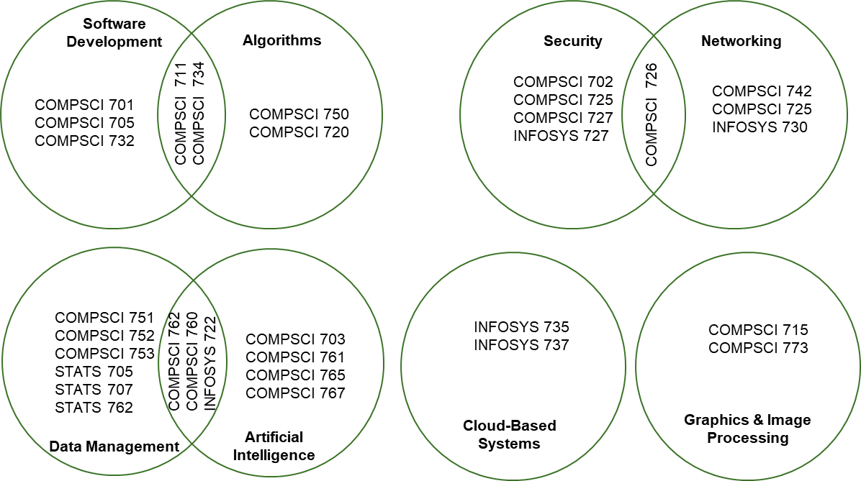

Figure 2 Professional skills course clusters
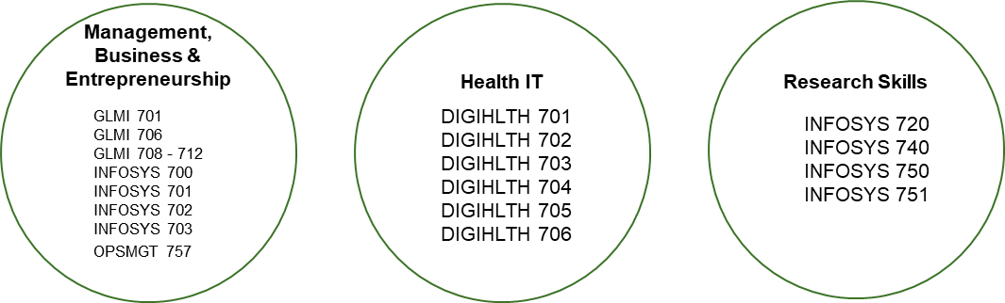

Table 1 Technical courses offered by semester in 2023
Semester 1 |  | Semester 2
COMPSCI 711 | Parallel and Distributed Computing | COMPSCI 701 | Creating Maintainable Software
COMPSCI 720 | Advanced Design and Analysis of Algorithms | COMPSCI 705 | Advanced Topics in Human Computer Interaction
COMPSCI 727 | Cryptographic Management | COMPSCI 715 | Advanced Computer Graphics
COMPSCI 732 | Software Tools and Techniques | COMPSCI 725 | System Security
COMPSCI 751 | Advanced Topics in Database Systems | COMPSCI 726 | Network Defence and Countermeasures
COMPSCI 752 | Big Data Management | COMPSCI 742 | Advanced Internet: Global Data Communications
COMPSCI 760 | Advanced Topics in Machine Learning | COMPSCI 750 | Computational Complexity
COMPSCI 762 | Foundations of Machine Learning | COMPSCI 753 | Algorithms for Massive Data
COMPSCI 765 | Modelling Minds | COMPSCI 760 | Advanced Topics in Machine Learning
COMPSCI 773 | Intelligent Vision Systems | COMPSCI 761 | Advanced Topics in Artificial Intelligence
COMPSYS 701 | Advanced Digital Systems Design | COMPSYS 704 | Advanced Embedded Systems
COMPSYS 723 | Embedded Systems Design | COMPSYS 705 | Formal Methods for Safety Critical Software
COMPSYS 726 | Robotics and Intelligent Systems | COMPSYS 725 | Distributed Cyber-Physical Systems Design
ELECTENG 722 | Modern Control Systems | ELECTENG 726 | Digital Communications
ELECTENG 733 | Digital Signal Processing
 |  | INFOSYS 722 | Data Mining and Big Data
STATS 707 | Computational Introduction to Statistics | INFOSYS 727 | Advanced Information Security
STATS 762 | Regression for Data Science | INFOSYS 735 | Cloud Computing Architecture
 |  | INFOSYS 737 | Adaptive Enterprise Systems
 |  | STATS 705 | Topics in Official Statistics

Note that SOFTENG courses are NOT available to non-engineering students. You can choose COMPSCI courses as alternatives.

Table 2 Professional skill courses offered by semester in 2023
Semester 1 |  | Semester 2
DIGIHLTH 701 | Principles of Digital Health  (Previous course name: HLTHINFO 728) | DIGIHLTH 703 | New Zealand Health Data Landscape (Previous course name: HLTHINFO 725)
DIGIHLTH 702 | Health Knowledge Management (Previous course name: HLTHINFO 723) | DIGIHLTH 704 | Healthcare Decision Support Systems (Previous course name: HLTHINFO 730)
DIGIHLTH 705 | Digital Health Design and Evaluation | DIGIHLTH 706 | Health Data Analytics
INFOSYS 700 | Digital Innovation | INFOSYS 702 | Block Chain
INFOSYS 701 | Global Outsourcing | INFOSYS 720 | Information Systems Research
INFOSYS 703 | Managing with Artificial Intelligence | INFOSYS 740 | System Dynamics and Complex Modelling
INFOSYS 751 | Research Methods - Qualitative | INFOSYS 750 | Research Methods - Quantitative
GLMI 701 | Competing Internationally | GLMI 706 | Working in an Age of Uncertainty
GLMI 708 | Critical, Creative and Strategic Thinking | GLMI 707 | Responsible Business and Sustainability
GLMI 710 | Innovation and Knowledge Management | GLMI 709 | Creating Global Ventures
GLMI 711 | Strategic Entrepreneurship and Innovation
GLMI 712 | Understanding and Managing Creativity
OPSMGT 757 | Project Management
SCIENT 701 | Accounting and Finance for Scientists
STATS 779 | Professional Skills for Statisticians

Technical courses not available in 2023: COMPSCI 702, 703, 734, 767, INFOSYS 730
Prerequisites: Knowledge in Java
Prerequisites: At least one stage II statistics courses or have a degree in CS or Engineering
This course is cancelled in 2023
This course will be counted as an elective
This course is cancelled in 2023

