Cryostat Sectioning of Frozen Samples
General Steps
- Reserve Cryostat in Histology Record Book in the Histology lab.
- Precautions Before Blade Handling:
  - Lock hand wheel to immobilize the block
  - Cover exposed blade with anti-roll plate
  - Leave 'Cryostat in use' note
- Avoid storing tissue in cryostat overnight due to defrost cycle.
- Unlock/Lock Cryostat using the key symbol on the top control panel
- 'LOCKED' sign prevents parameter changes for stability.
- Set optimal temperatures for tissue sectioning (CT 1–3°C lower than OT). Refer to pg52 of Leica CM3050 Cryostat instruction manual.
- Control cryochamber light with the lightbulb symbol.
- Monitor temperature fluctuations when cryochamber window is open.
- Refer to manual for troubleshooting (section 6.2) if needed.

Set Up Method
- Equipment and Materials:
  - Leica CM3050S cryostat
  - PPE: lab coat, safety glasses, gloves
  - Tork tissues, Cryomold, Frozen Section Compound, Specimen discs
  - Superfrost Plus Glass Slides, Disposable knife blades
  - Stainless-steel forceps, large and small brushes
  - Fresh frozen tissue
- Set up 30 mins before sectioning for equilibration.
- Unlock cryostat, turn on lights, and set parameters (thickness, CT, OT).
- Ensure hand wheel is locked, microtome angle at 5°, and specimen holder homed using the double up arrow symbol on the left control panel 2
- Leave materials at room temperature.
- Place tools inside cryostat, add fresh frozen tissue.
- Wipe disposable blade, insert, and cover with anti-roll plate.
- Display 'Cryostat in use' note.

Frozen Tissue Block Preparation
- Orient and freeze tissue in cryomold with OCT.
- Cover chuck surface with OCT.
- Attach tissue to chuck, wait for OCT to turn white.
- Clamp block, adjust holder using the single up and down arrow symbols on the left control panel 2 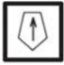 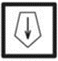 , ensure contact with the blade.

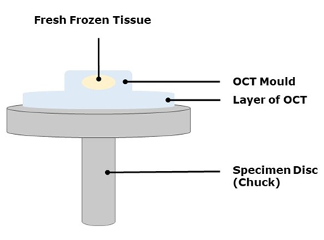
Trimming Procedure
- Set trimming thickness to 30 µm using the plus and minus symbols on the left control panel 2.
- Turn on 'Trim' light, unlock hand wheel, and trim block 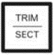 .
- Clear debris, switch off 'Trim,' cut and discard the first 30 µm section.
- Lock hand wheel.
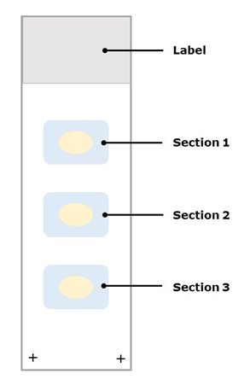
Sectioning Procedure
- Align anti-roll plate, unlock hand wheel.
- Section block in a slow, uniform motion.
- Cut and mount one section at a time.
- Uncurl sections on a labeled slide.
- Mount 3–4 sections per slide.
- Store slides in a chilled box.

Clean Up Method
- Ensure hand wheel is locked, anti-roll plate covers blade.
- Remove blocks and slides from cryochamber.
- Partially defrost OCT-embedded tissue for removal.
- Clean forceps and brushes with diluted trigene, rinse, and dry.
- Discard used blade into the yellow sharps bin.
- Dispose of debris, wipe cryochamber with ethanol, clean anti-roll plate.
- Clean exterior surfaces of the cryostat.
- Evaporate ethanol, set cryostat to -15°C, turn off light.
- Lock cryostat before leaving.

